ZFGL01-FUNCTIONAL AREA ADJUSTMENT


This simulation describes how to use T-Code ZFGL01 to perform Functional Area Adjustment postings in Statutory and/or Tax ledger(s) for the entities requiring such adjustments. Functional Area Adjustment process is aimed to reclassify P&L amounts from nature (e.g. Payroll, Rent, etc.) to function (e.g. Administration, Miscellaneous, etc.).

Note that not all entities have such requirements. You should contact your BSC GL Team if you have new or changed requirements of Functional Area Adjustments.

Click to continue.

Explanation | Screenshot
[1] ZFGL01 is now entered in the Transaction box. | 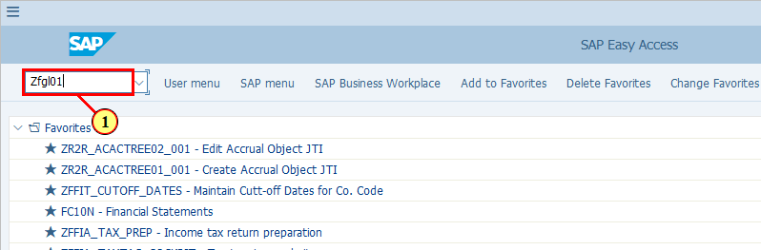
  - Functional Area Adjustment process is only applicable to limited entities which have such requirements.  - Variants have been set up for these entities based on the requirements collected during the S4F project and BSC GL Teams are responsible for maintaining these variants.  - The variants in different entities can be very different therefore you should choose the correct variant before executing the transaction.  Click to continue.  [2] Click Get Variant... .  You can also press Shift+F5. | 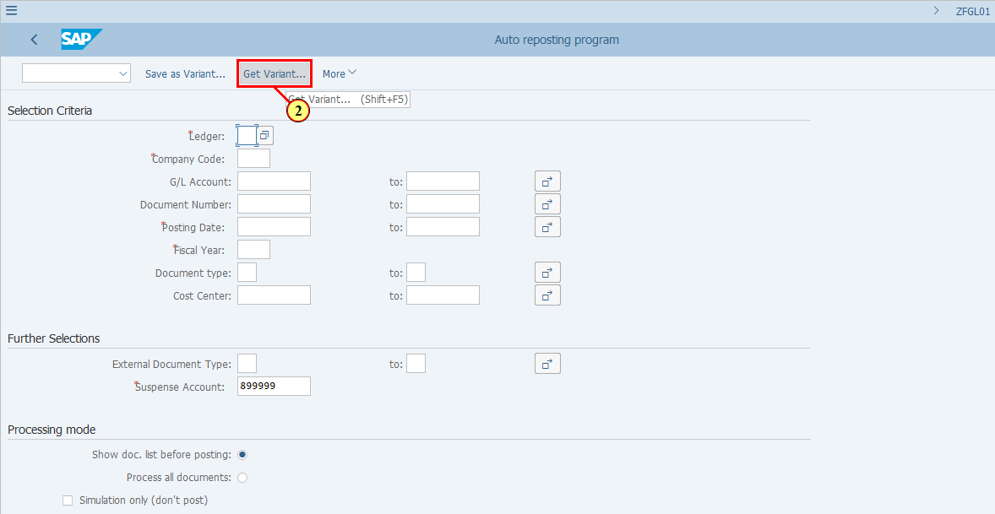
[3] The Created By field is cleared. | 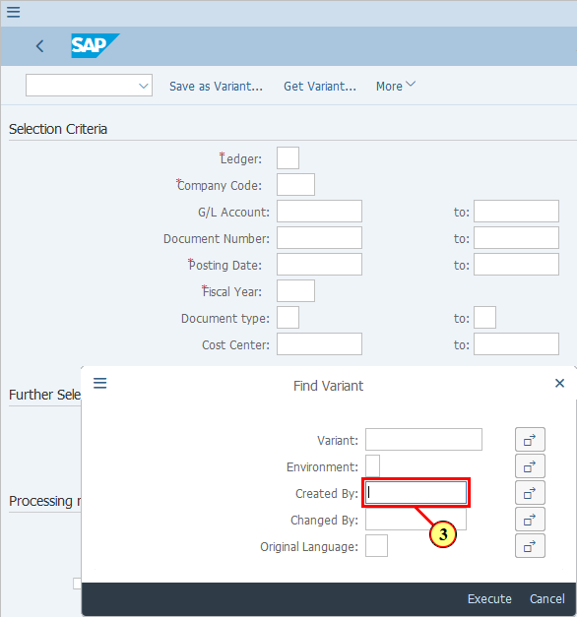
[4] Click Execute .  You can also press F8. | 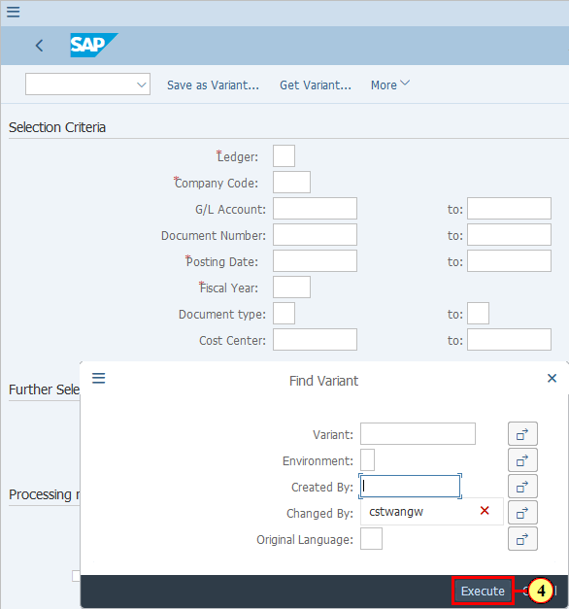
  Although the Functional Area Adjustment variants look similar to other variants used in Financial Closing Cockpit (FCC), i.e. it begins with C, it is important to know that at the moment this transaction is included in FCC as a Note task only, which means it needs to be executed outside of FCC (as described in this simulation) and after that the status of the corresponding FCC task needs to be manually updated. Any important output from the execution needs to be saved too.  Click to continue.  [5] Here you can see the variants already created.  Click Variant name . | 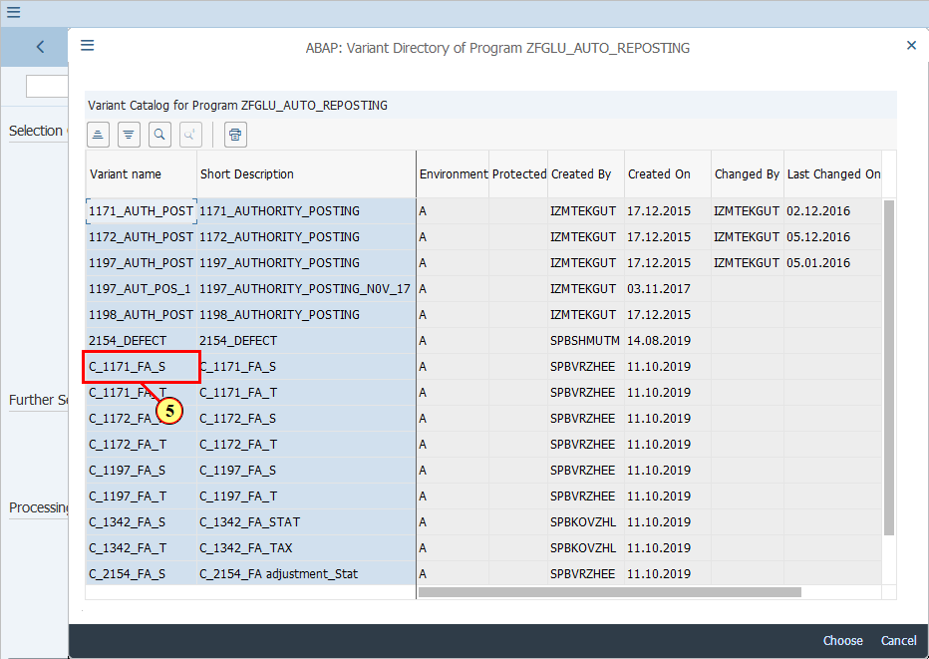
[6] Click Choose .  You can also press F2. | 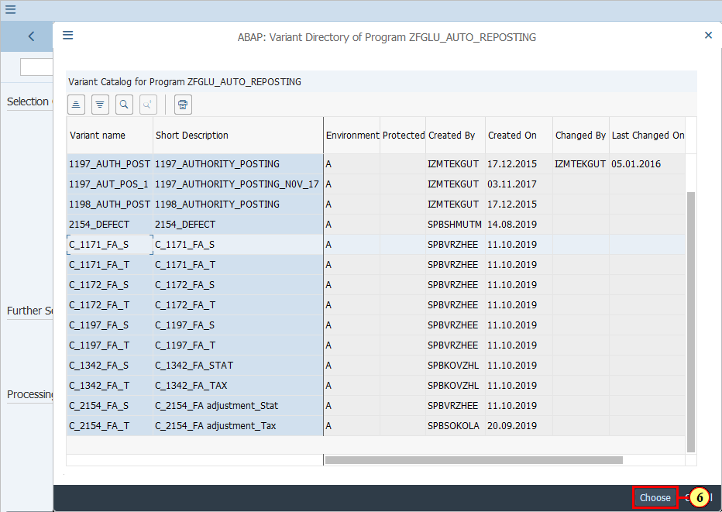
[7] The *Ledger field is filled out.  Note that this transaction can perform Functional Area Adjustments for One Ledger at a time. So if you have requirements in both ST and TX ledgers, you will need two separate variants. Only ST and TX are allowed here. | 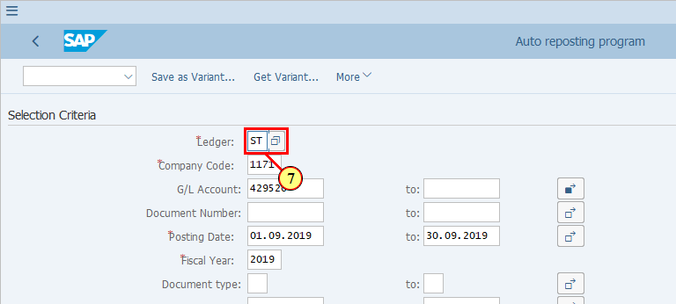
[8] The *Company Code field is filled out. | 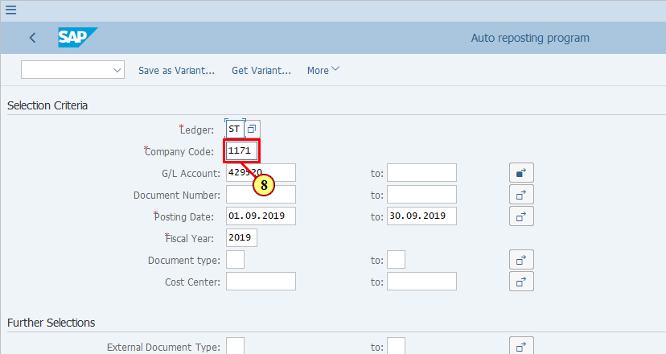
  These are the G/L accounts values/ranges that are in scope of Functional Area Adjustments. This can be very different in different entities and for different ledgers. BSC GL Teams are responsible for liaising with entities and making sure these values/ranges are up to date.  [9] Click Multiple Selection .  You can also press Active. | 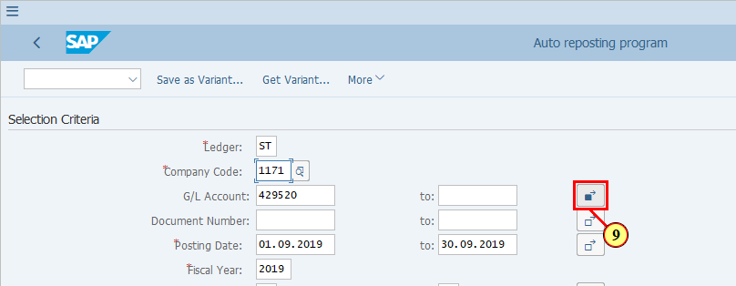
[10] ENTER is now pressed to continue after seeing the warning message. | 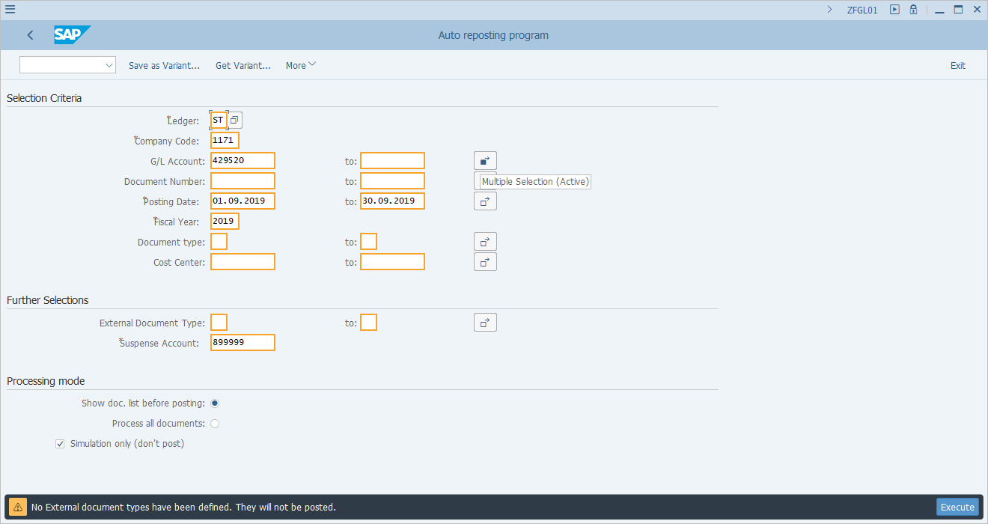
  You can review (entity and BSC) or maintain (BSC responsibility) the G/L accounts which are subject to Functional Area Adjustments. | 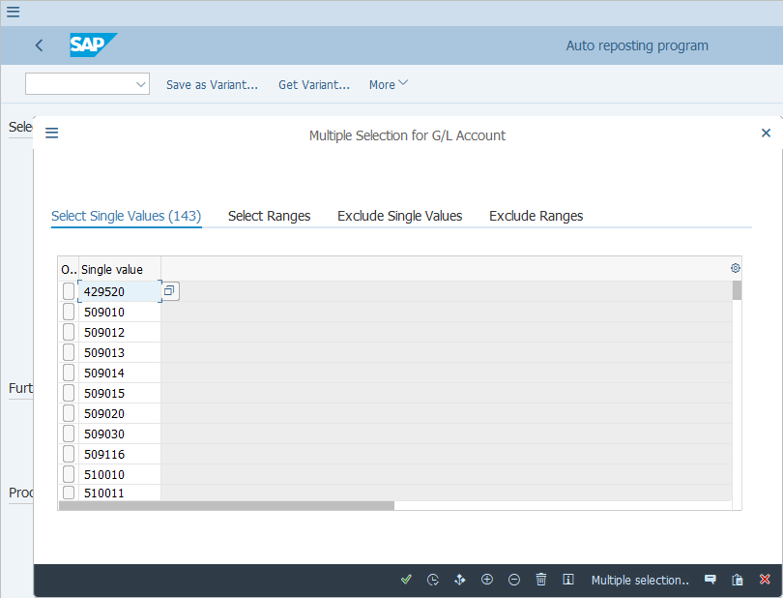
[11] Click Copy .  You can also press F8. | 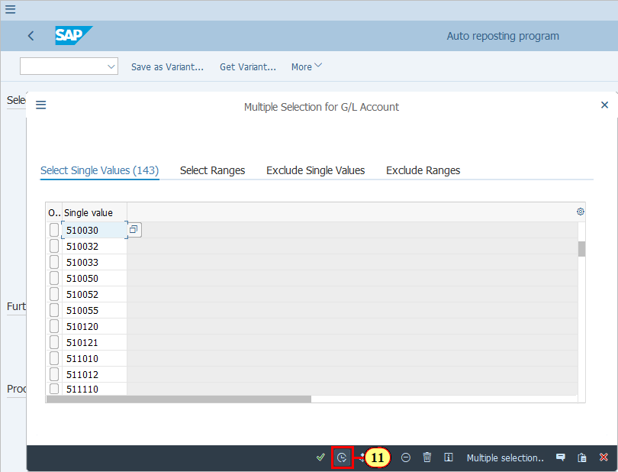
  Here you have the option of performing Functional Area Adjustments for selected documents only. However this is normally not used because the expectation is to perform Functional Area Adjustments once only for a given period at the end of the month. You may need to use this field for specific corrections if something goes wrong in the overall Functional Area Adjustment runs.  Normally we will select the posting date for the whole period and execute the transaction. | 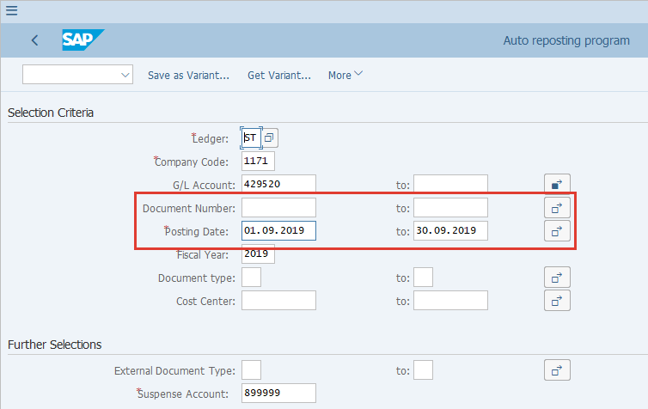
[12] The *Posting Date field is filled out. | 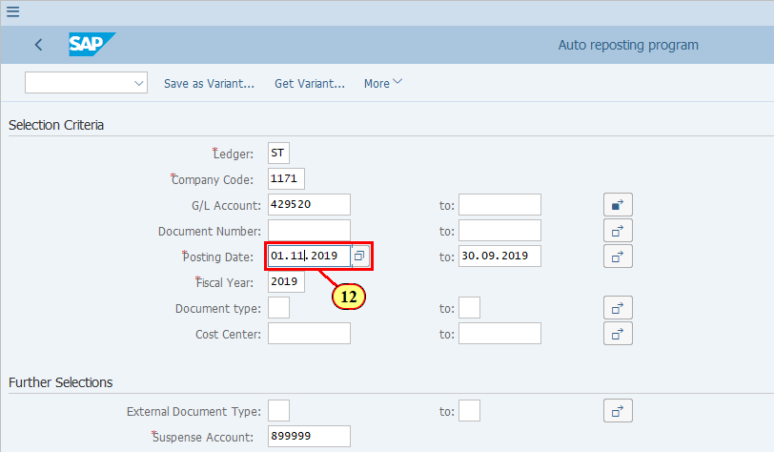
[13] The to field is filled out. | 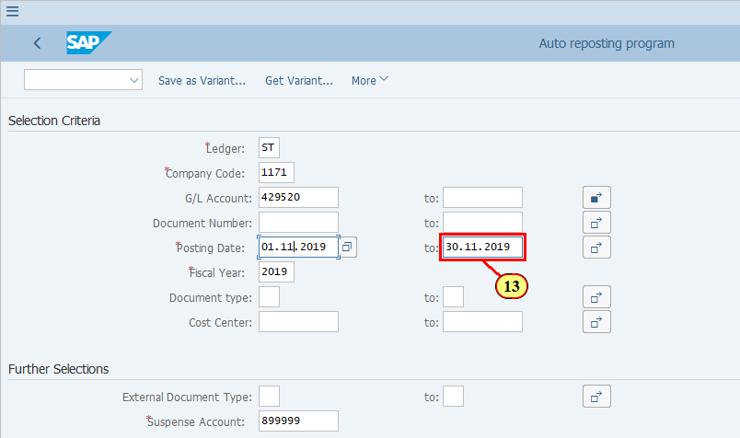
[14] The *Fiscal Year field is filled out. | 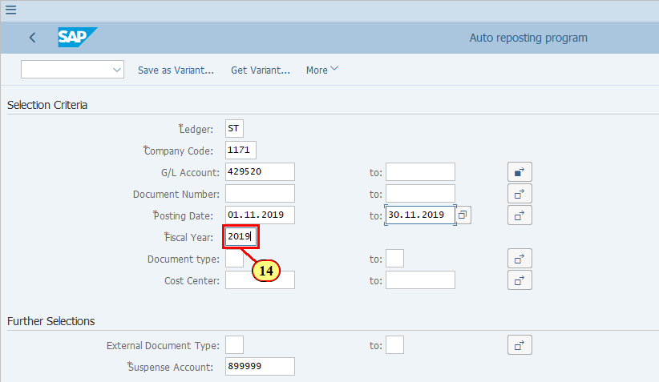
  Here you have the option of performing Functional Area Adjustments for selected Document Types or Cost Centers only. However this is normally not used because the expectation is to perform Functional Area Adjustments once only for a given period at the end of the month. You may need to use this field for specific corrections if something goes wrong in the overall Functional Area Adjustment runs. | 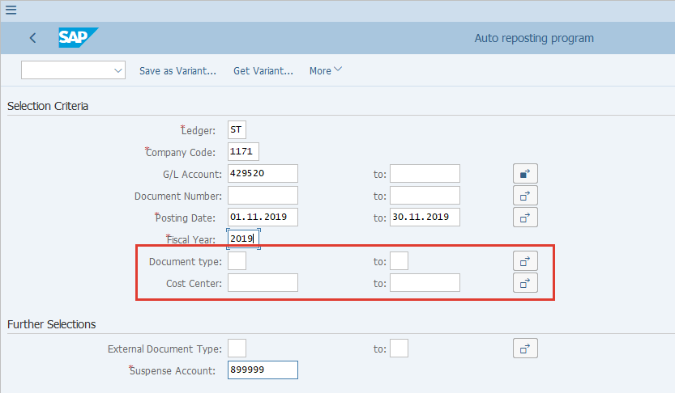
  External Document Type allows to indicate which Document Types should be reposted by Functional Area with original document type.  Example: If we specify document type FA here, then FA depreciation will be re-classified by Functional Area with document type FA, same as the original Document Type. If we leave this field empty, then all monthly subject items will be re-classified with Document Type SA.  Normally this parameter is not used unless there's such requirements from specific entities. | 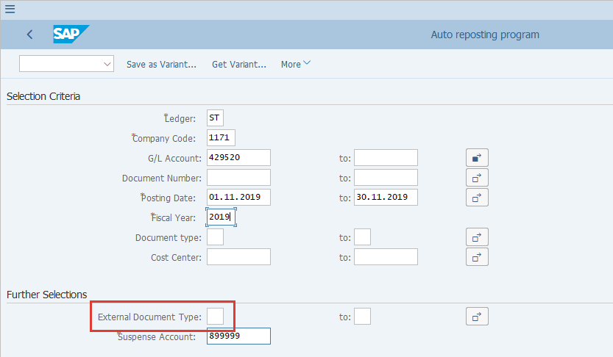
[15] The *Suspense Account field is filled out.  This is the G/L account that is used to balance FA adjustment to zero. It should always be 899999 and should not be changed | 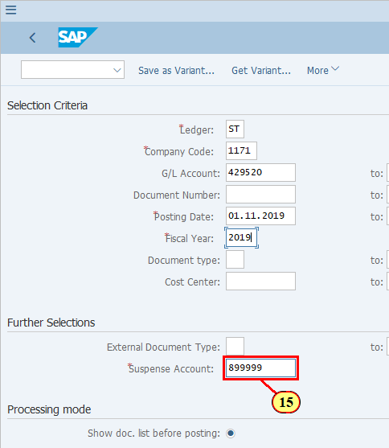
[16] Show doc. list before posting is double-clicked.  Select this option to allow document to be displayed before postings are made. This is selected by default. | 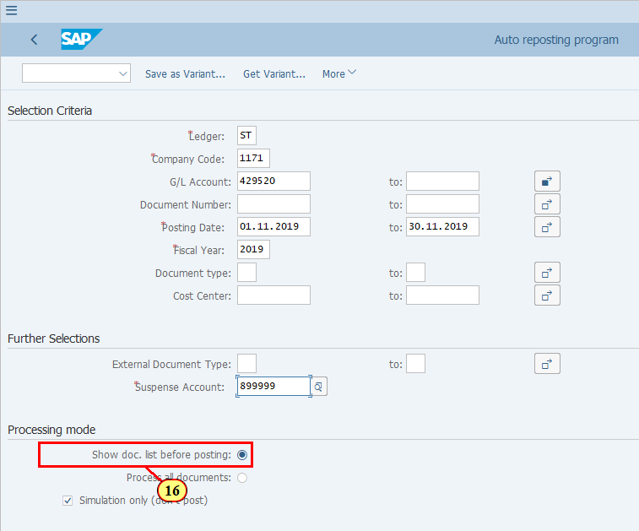
  Process all documents: Indicator to process all documents immediately, i.e. the list is not shown before user can confirm that the Functional Area Adjustment documents should be processed (posted).  We normally do not select this indicator in the variants that are already set up. | 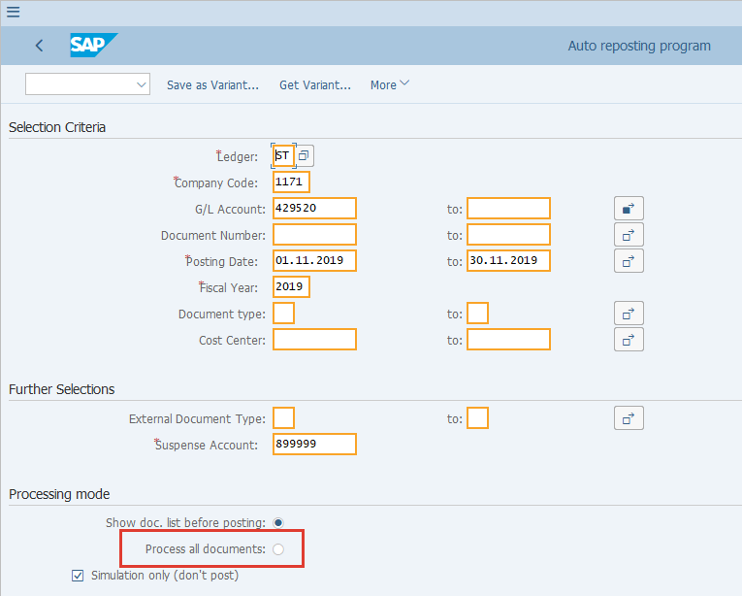
[17] Simulation only (don't post) is double-clicked.  This is equivalent to Test Run. Recommended for the first execution in order to validate postings correctness before Update Run. | 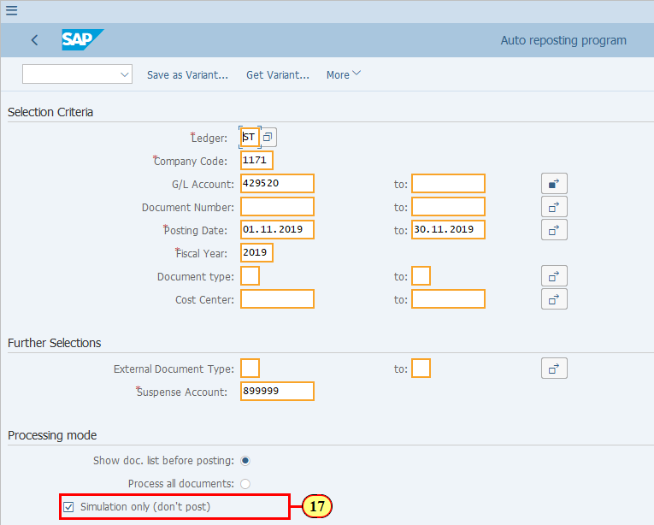
[18] Click Execute .  You can also press F8. | 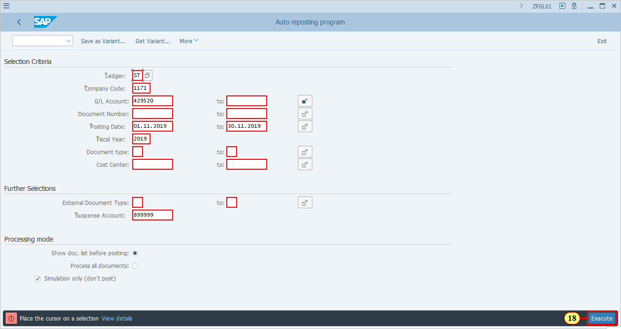
[19] Press ENTER to confirm the warning message and continue. | 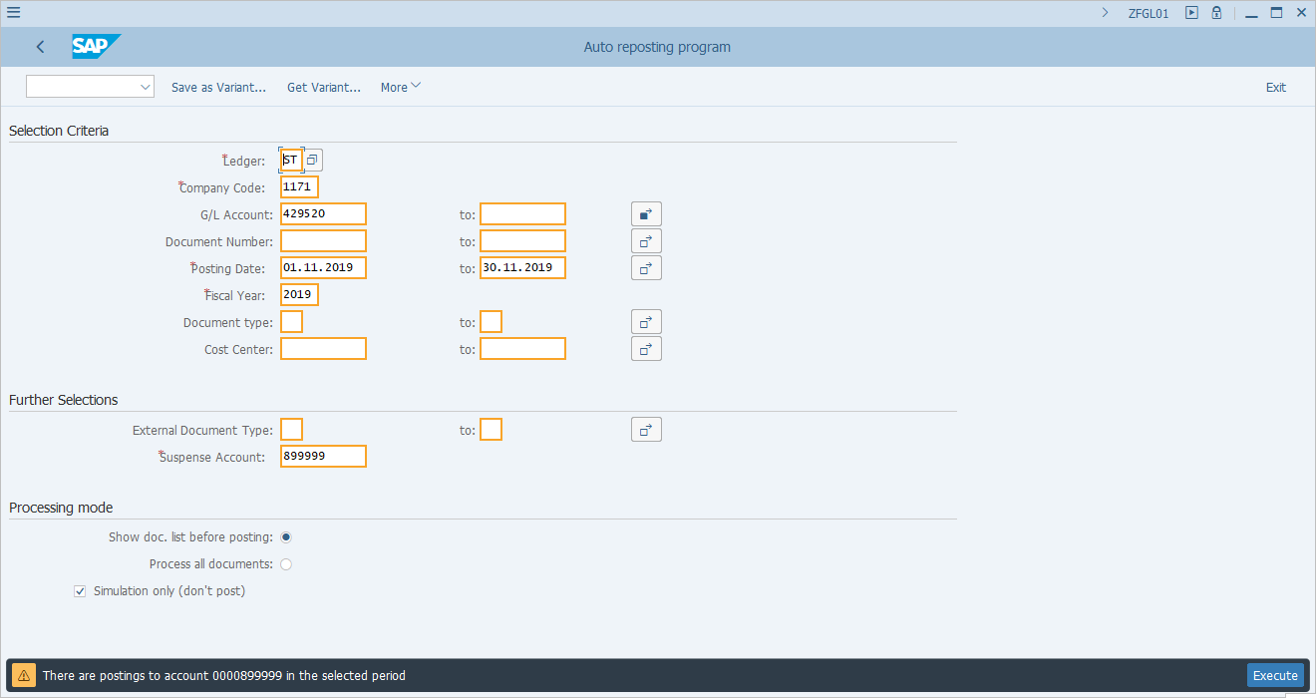
  As we have selected to show the list of documents before processing, you can now see the proposed list of documents to be posted. Important fields explained:  - Ledger: ST or TX, based on your selection in the variant  - CoCode: Company code in your variant  - DocumentNo: The original document which included the G/L accounts that were selected for Functional Area Adjustments. If you display this document number you will be able to find a P&L posting line which contains a Functional Area that corresponds to the Functional Area Adjustments account used for the proposed posting, e.g, 892000 for functionl area 2000 (General Production Expense).  - Fiscal Yr: Fiscal Year of the document selected for Functional Area Adjustments  - Type: Document Type of the document selected for Functional Area Adjustments  - Posting Date: Postng Date of the document selected for Functional Area Adjustments  - Currency: Document Currency of the document selected for Functional Area Adjustments  - Key: Proposed posting key of the Functional Area Adjustment posting  - G/L Acc: Proposed accounts to be used for Functional Area Adjustment posting  - Amnt in TC: Proposed document currency amount in the Functional Area Adjustment posting. Same as displayed in FAGLL03/FAGLL03H.  - Amnt in CC: Proposed LC1 amount in the Functional Area Adjustment posting. Same as displayed in FAGLL03/FAGLL03H.  - Amnt in GC: Proposed LC3 amount in the Functional Area Adjustment posting. Same as displayed in FAGLL03/FAGLL03H.  - Alt. Acct: The alternative account of the corresponding G/L to be used for Functional Area Adjustment postings  Click to continue.  [20] To simulate posting, select the proposed posting line.  E.g. is now selected. | 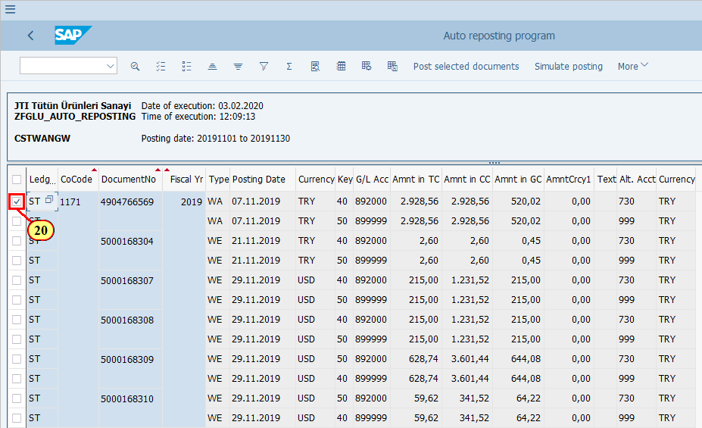
[21] Click Simulate posting .  You can also press F7. | 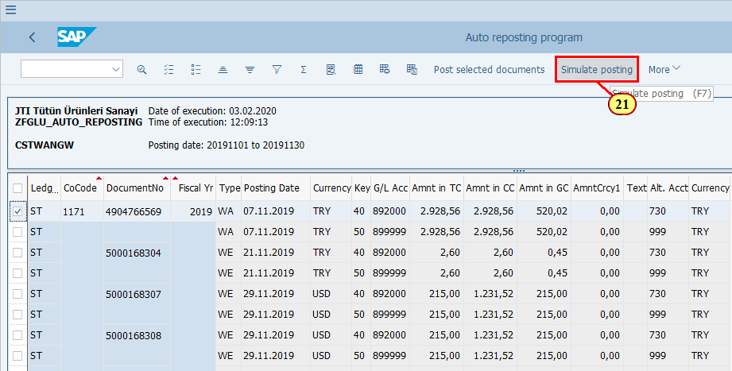
  The debit and credit shown are simulated the postings of the item you selected.  [22] Click Continue . | 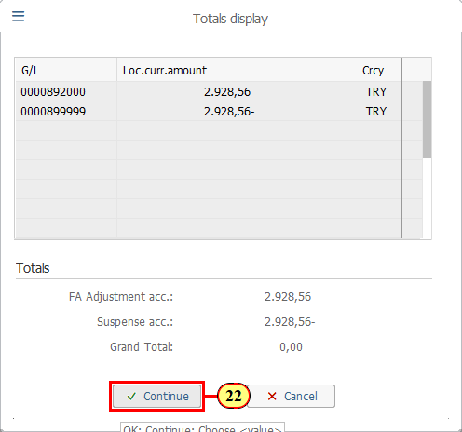
  This log shows whether the posting has been simulated successfully or if any error has occured.  You may select all the items and simulate all proposed postings.  [23] Click Back .  You can also press F3. | 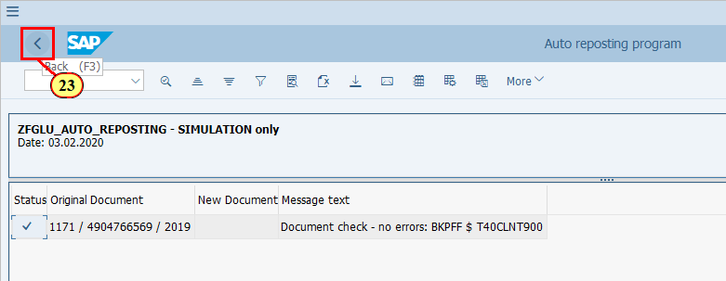
[24] Click on the top to select all items. | 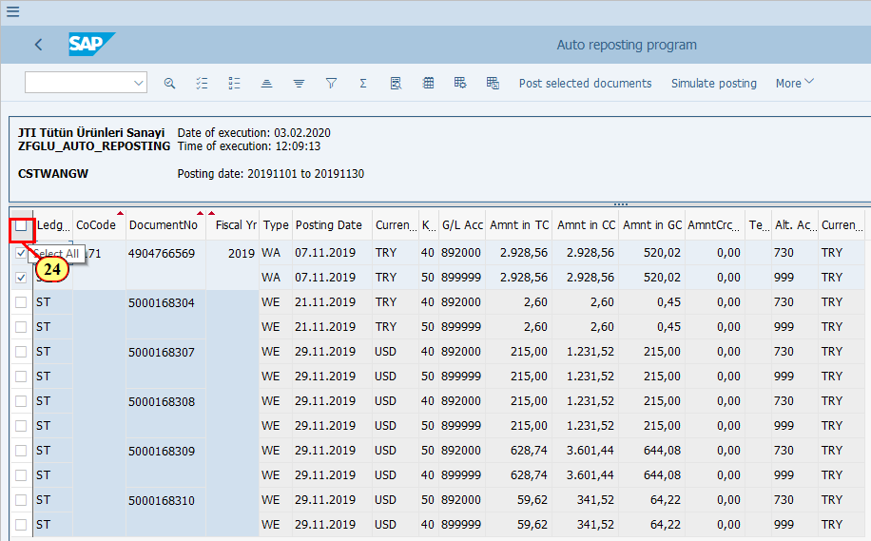
[25] Click Simulate posting .  You can also press F7. | 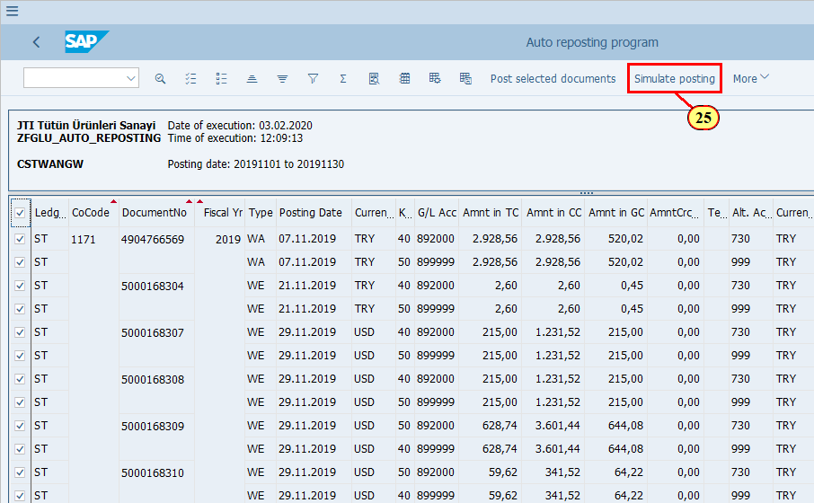
  This is the simulation of all the selected items. The amounts represent the total of all the selected debits and credits.  [26] Click Continue . | 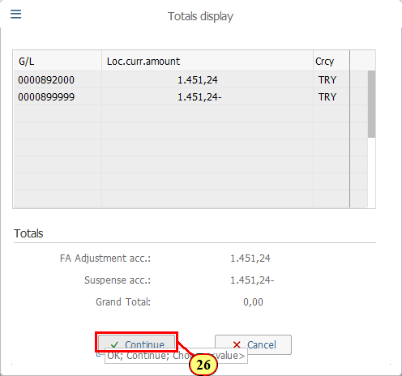
  As you can see all the proposed documents have been simulated successfully.  [27] Click Back .  You can also press F3. | 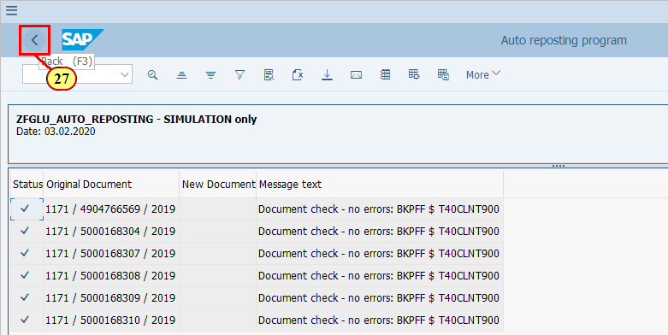
[28] Click Back .  You can also press F3. | 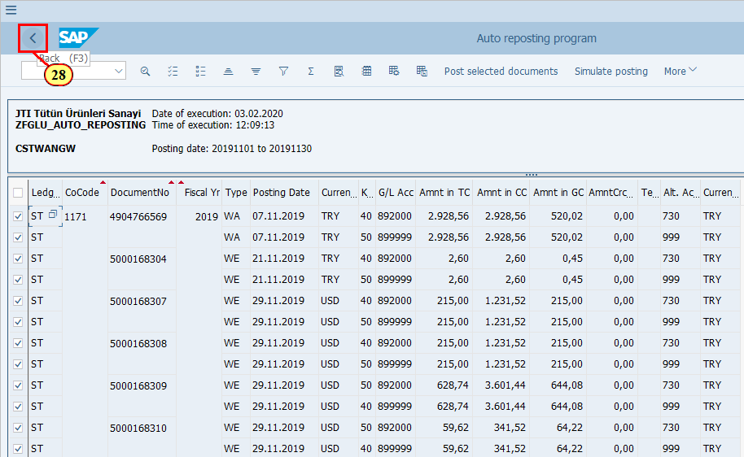
  Now we can remove the Simulation checkbox and do an Update Run.  [29] Click Simulation only (don't post) . | 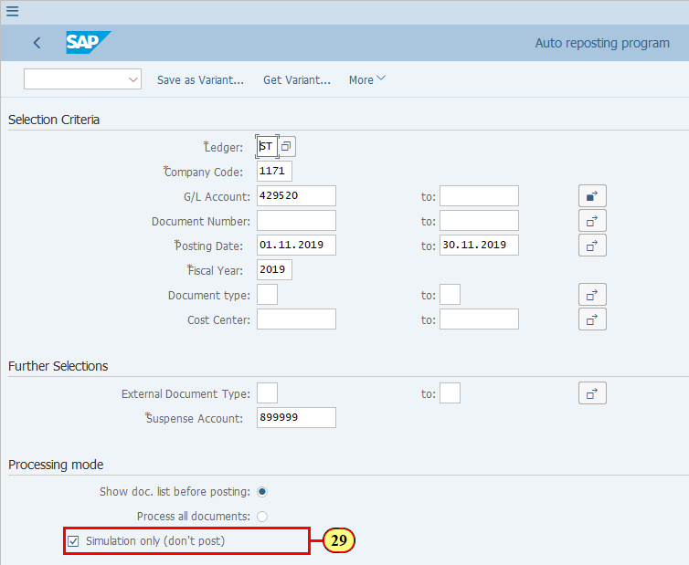
[30] Click Execute .  You can also press F8. | 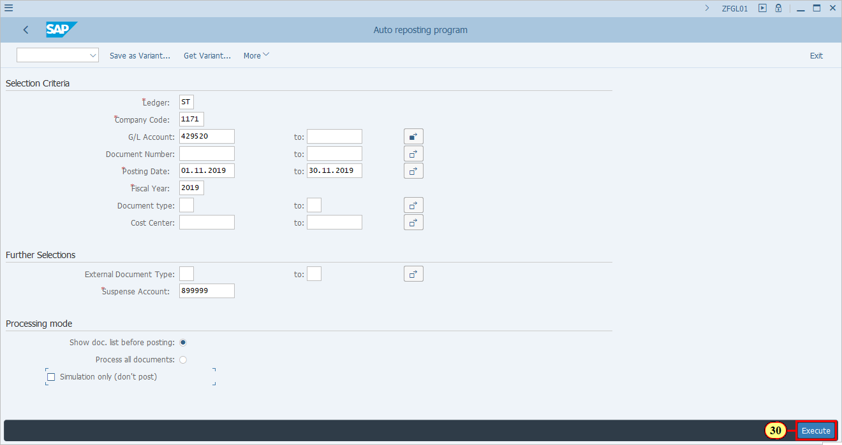
[31] ENTER is now pressed to confirm the warning message and continue. | 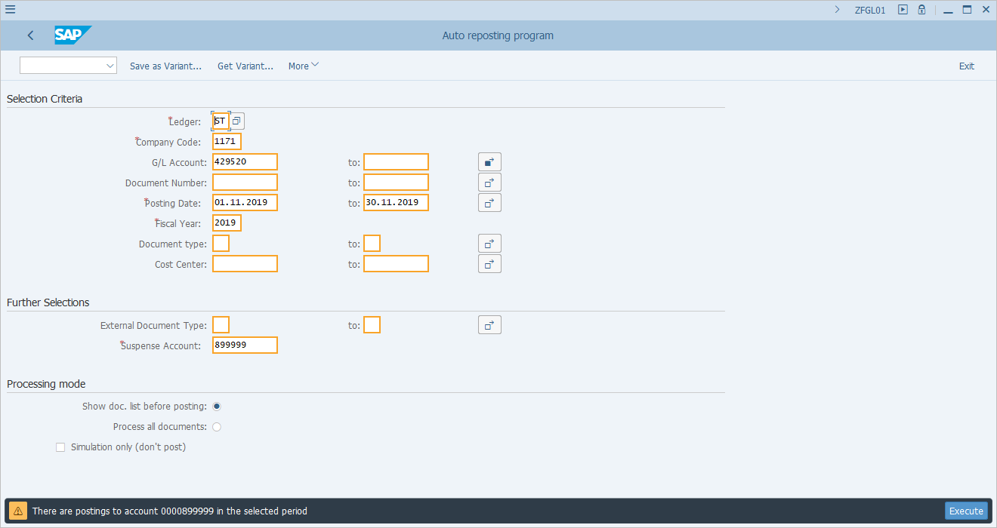
  To post the documents:  - Select all documents  - Click button "Post selected documents"  Before making the postings, you may want to download this list so that you can attach it to the corresponding FCC task as an evidence. To download this list, use More->List->Export from the menu.  [32] Click to select all items. | 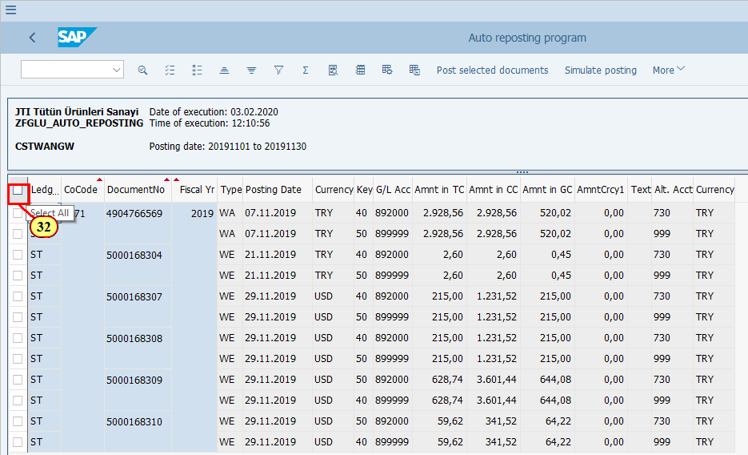
[33] Click Post selected documents .  You can also press F8. | 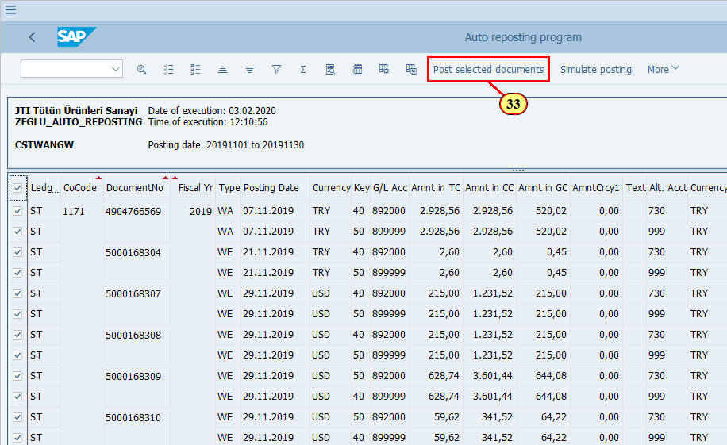
  As we have selected all the items, the debit and credit accounts and amounts shown here are for all the items we selected. | 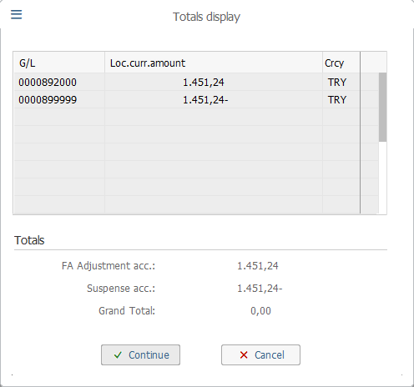
[34] Click Continue . | 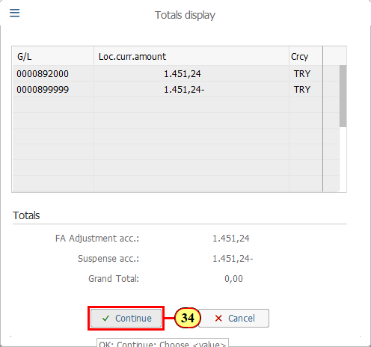
  The messages indicate that the documents have been posted successfully. You may display the documents via FB03 or FAGLL03/FAGLL03H.  You may also want to download this list as evidence to ZFGL01 execution. Follow menu path More->List ->Export.    We have now completed the basic simulation of ZFGL01.  In the next few steps, we will switch to FAGLL03 to take a look at the documents posted. Then we will switch back to ZFGL01 to see whether we can re-run this T-code after the Functional Area Adjustments are already posted.  Click to continue. | 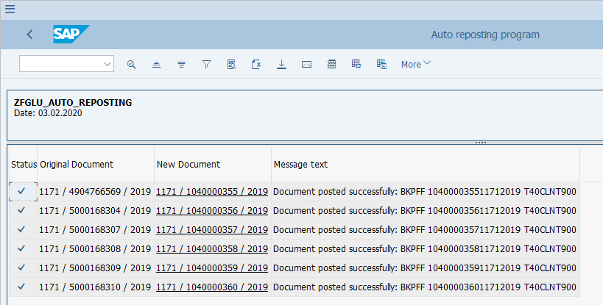
  In FAGLL03 - G/L Line Items report, we would like to see the postings we just made via Functional Area Adjustment ZFGL01.  There are many ways you can find such documents, for example:  - You can use Document Numbers from the ZFGL01 log as an additional selection criterion  - You can put the G/L accounts used, together with the posting date range as selection criteria  - If you know the original FI document numbers based on which the Functional Area Adjustments were posted, you can put those document numbers as Reference to search for line items posted with those documents as reference documents.  - You may also use Document Type as we know Functional Area Adjustments are posted with Document Type SA unless you specify using the original Document Type. However, you should note that there are also other transactions posting documents with Doc Type SA, such as AP/AR Regrouping for 3rd party vendors/customers.  In our example, we know that all the Functional Area Adjustments are posted against the same G/L account 899999, we can simply use this account to find out the documents (if we do not know the document numbers).  Click to continue.  [35] The G/L account field is filled out. | 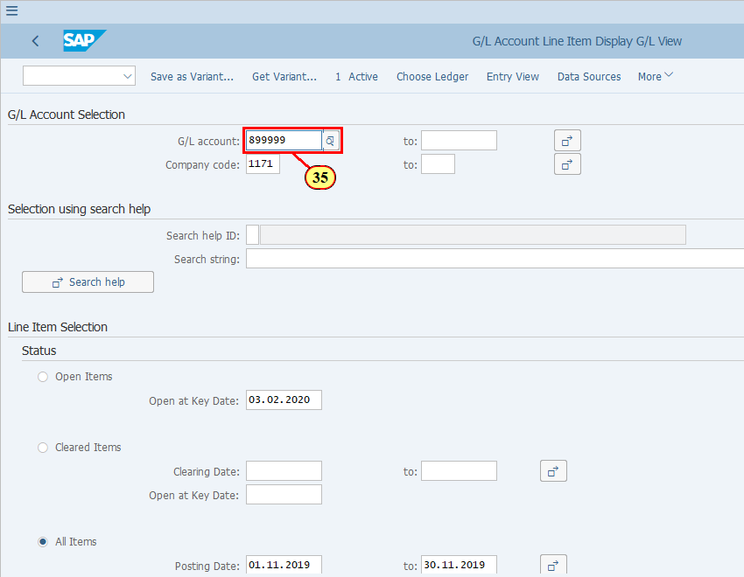
  Also make sure that your Posting Date range is correct.  [36] All Items is double-clicked. | 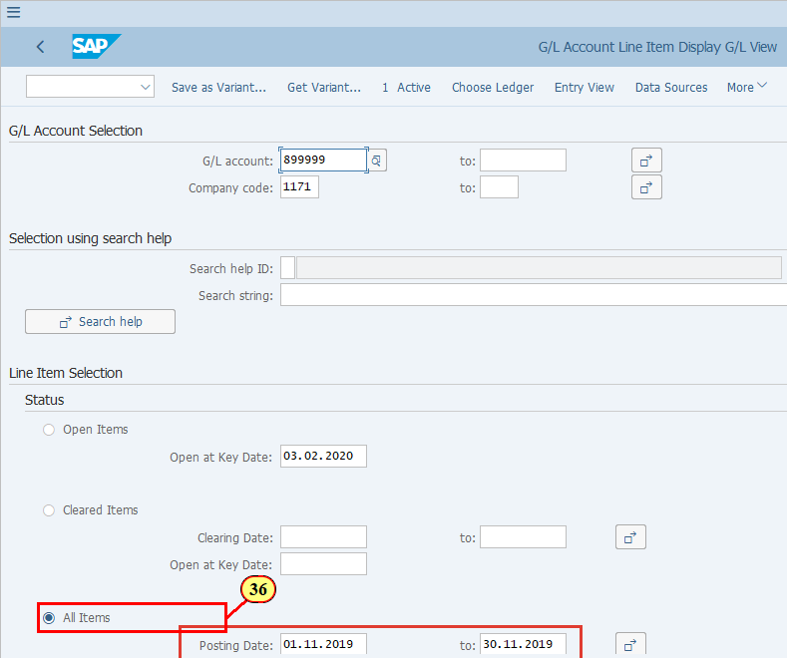
[37] Make sure you have selected the correct ledger. If not, use Change Ledger button to change it.  The Ledger field is filled out. | 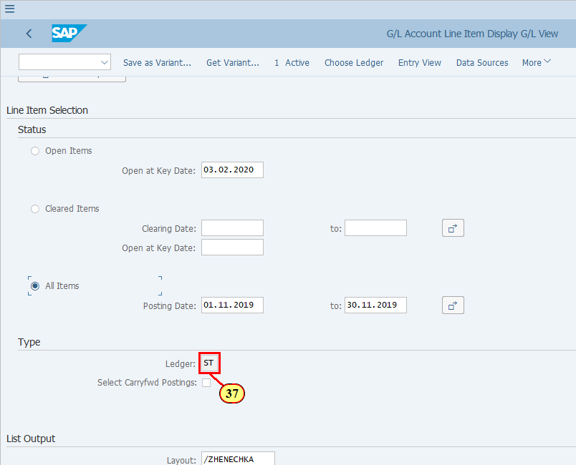
[38] Click Execute .  You can also press F8. | 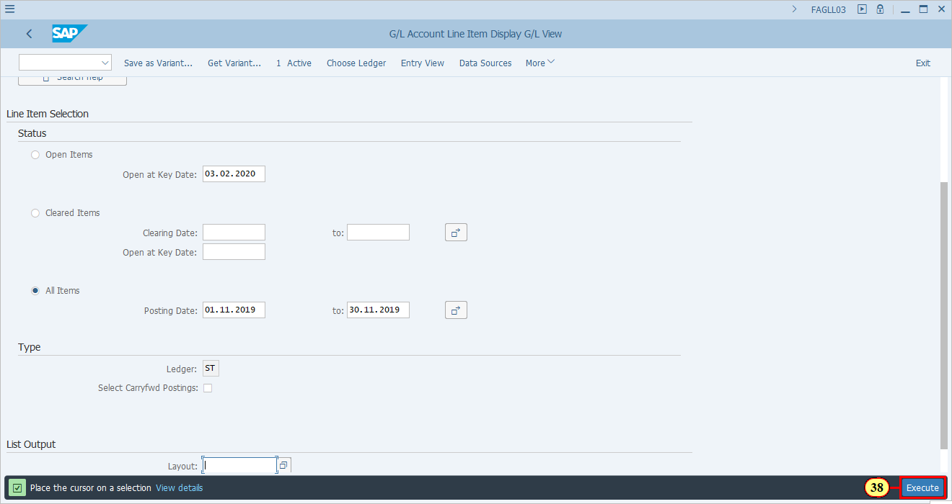
  You should notice that the Posting Date of the Functional Area Adjustment documents is not 30.11.2019, but the same Posting Date as used in the original documents in which the P&L was first posted. We will use an example to show this shortly.    You will now see the document numbers of the Functional Area Adjustment postings. | 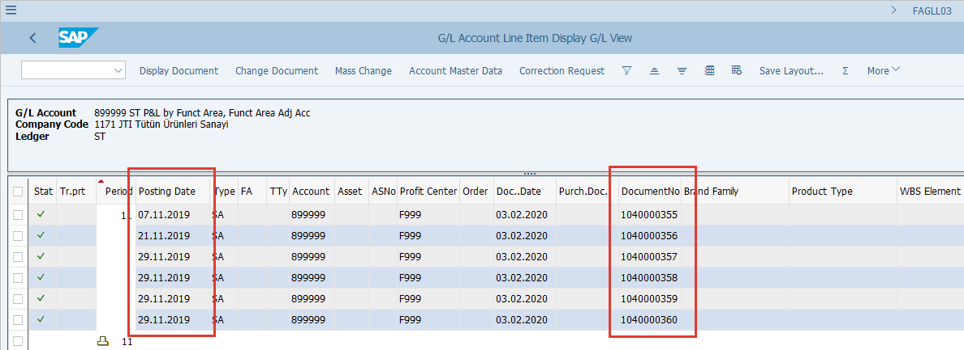
  You should also notice that the total of the Functional Area Adjustments amount in LC1 is shown here. (Same as shown when we simulated the postings for all items selected.) | 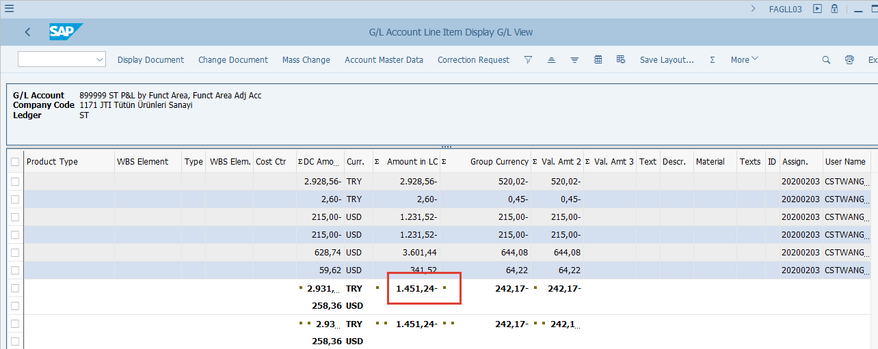
[39] To display a document, click on one of the fields of the line item, e.g. Posting Date column for the first document shown here. | 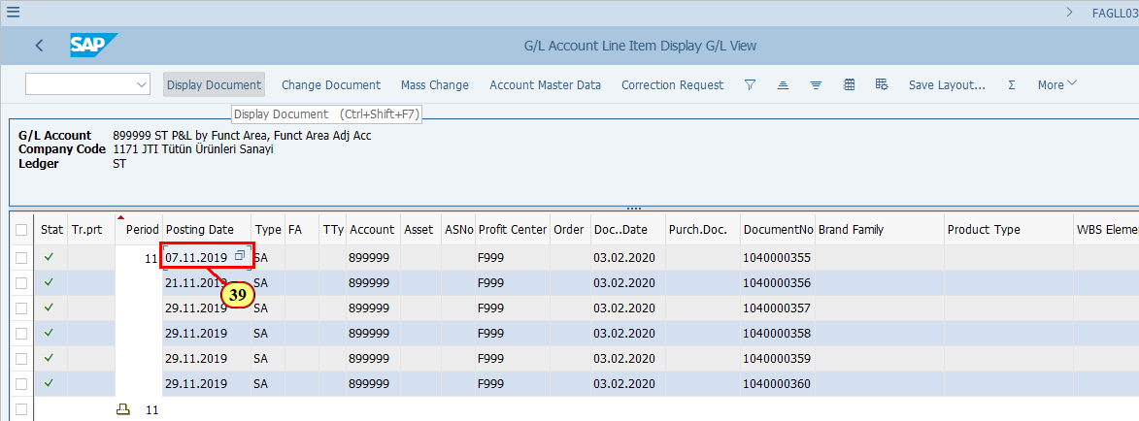
[40] Click Display Document .  You can also press Ctrl+Shift+F7. | 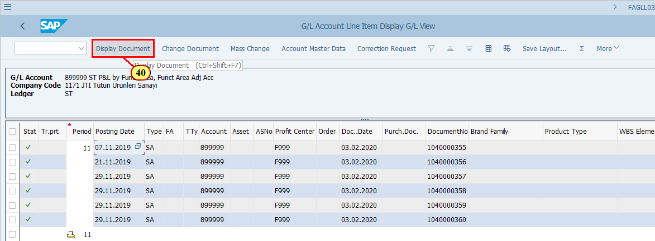
[41] Click Call Up Document Overview .  You can also press F9. | 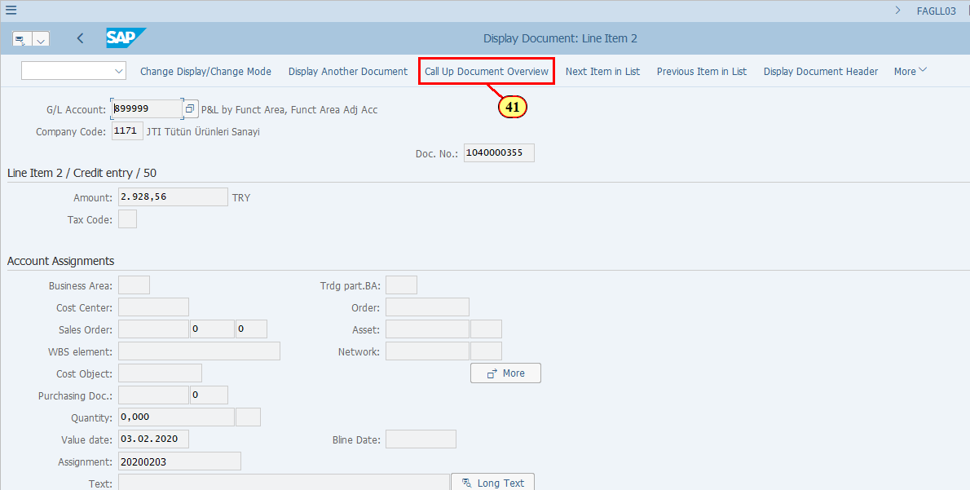
  This is the Functional Area Adjustment document.  You may validate the following key information, which is based on ZFGL01 execution:  - Company Code  - Ledger  - Document Date - the date when you executed ZFGL01  - Debit/Credit G/L accounts used for posting  The following information is based on the original P&L document:  - Posting Date / Posting Period  - Reference (original document number)  - Currency  - Amounts  - Profit Center  Click on when you are ready to continue. | 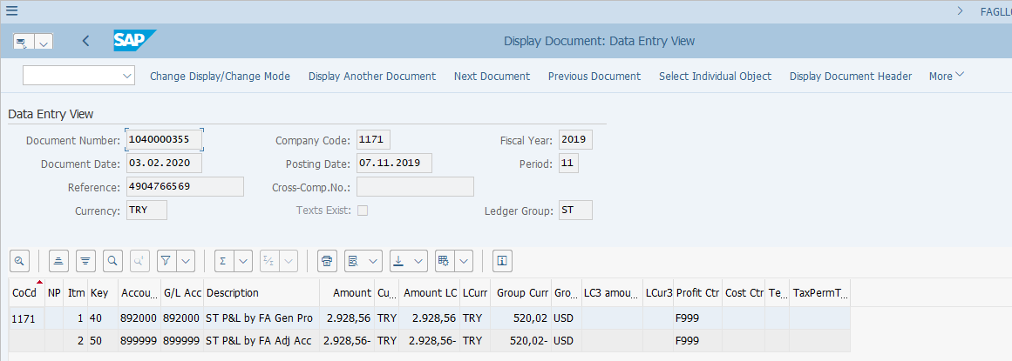
  Now we will open a separate SAP session to briefly take a look at the "original document" of the first Functional Area Adjustment posting.  [42] /ofb03 is now entered in the Transaction box. | 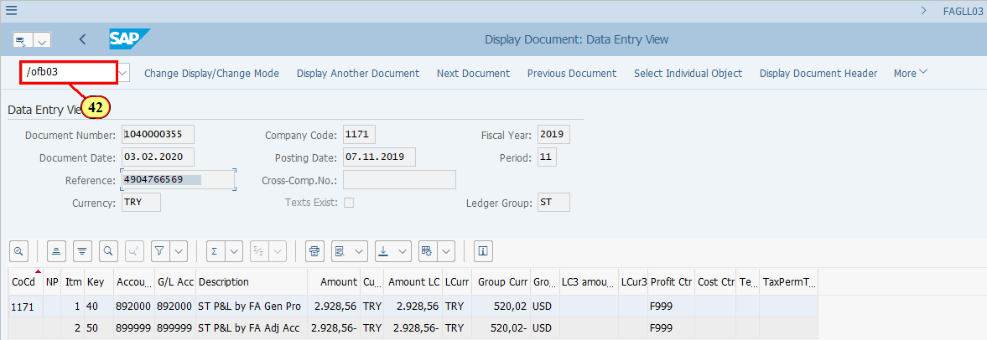
[43] We put the Reference number from the first Functional Area Adjustment document, then press ENTER . | 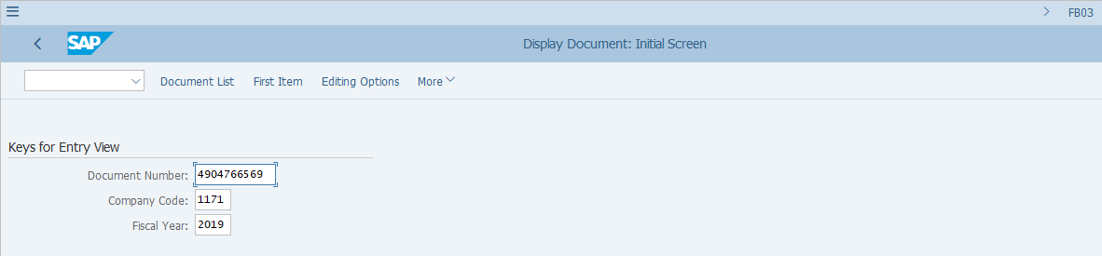
  You may reconcile the information that was taken from this original document as described earlier.  To show where the original information of Functional Area is, you may double click the P&L line (note this is the G/L selected in ZFGL01 variant) and then look for the Functional Area field.  [44] Description is double-clicked. | 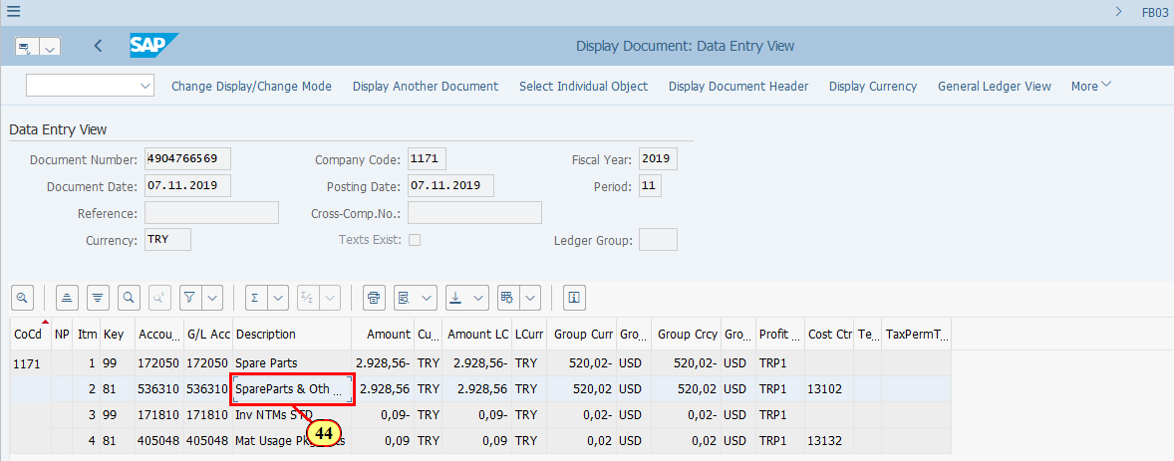
[45] Click More . | 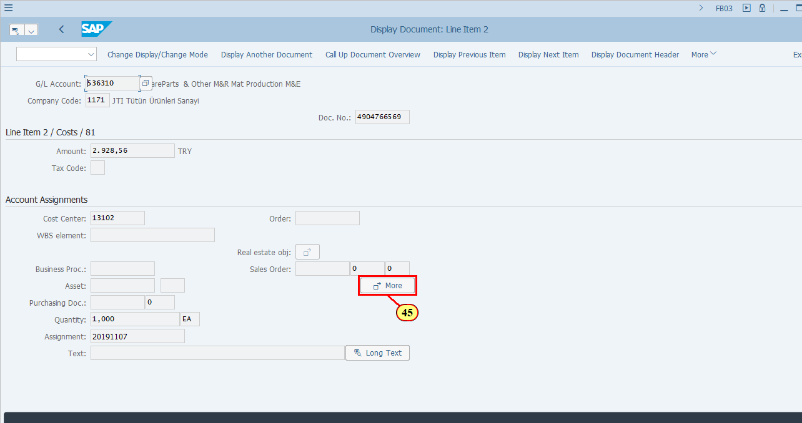
  As you can see here, the original Functional Area is 2000, based on which the Functional Area Adjustment (ZFGL01) transaction made a posting of Dr. 892000 Cr. 899999. | 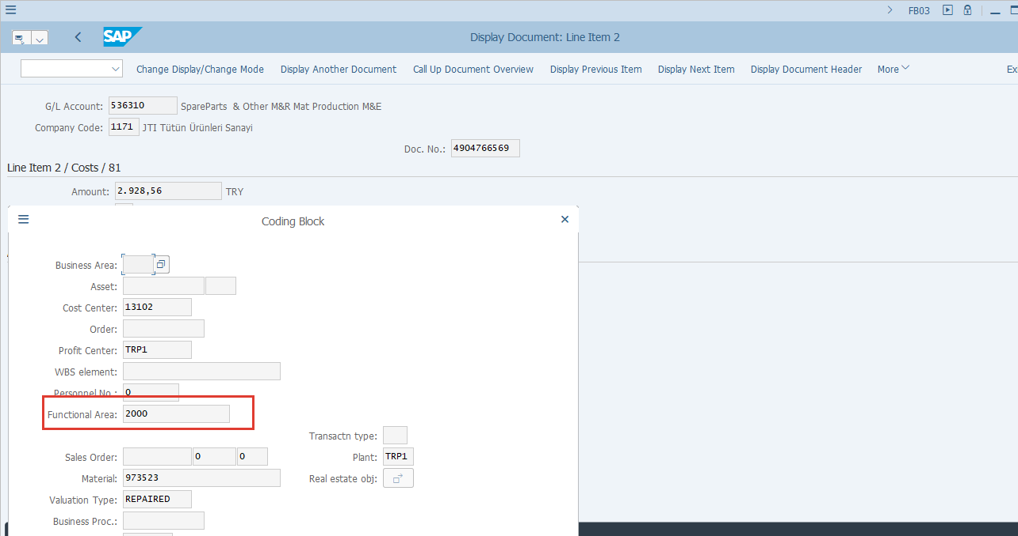
  In the next few steps, we will demonstrate that the transaction ZFGL01 can't be executed again if a Functional Area Adjustment has already been posted for a given original document.  Click to continue.  [46] Back on the ZFGL01 screen.  Click Simulation only (don't post) to execute the transaction in update run mode. | 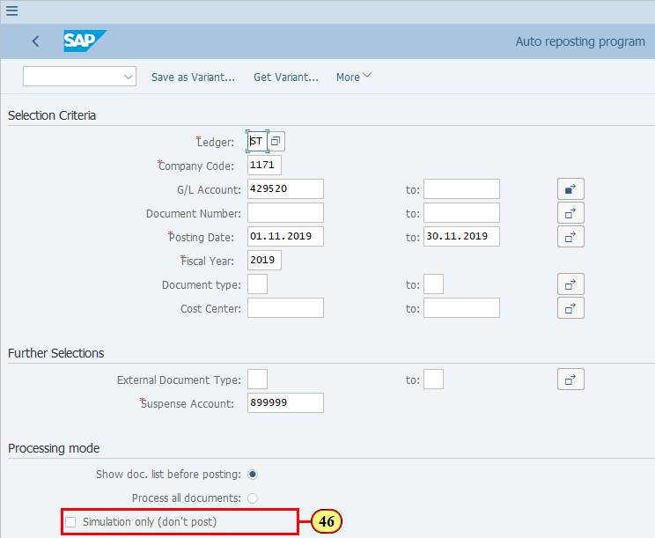
[47] Click Execute .  You can also press F8. | 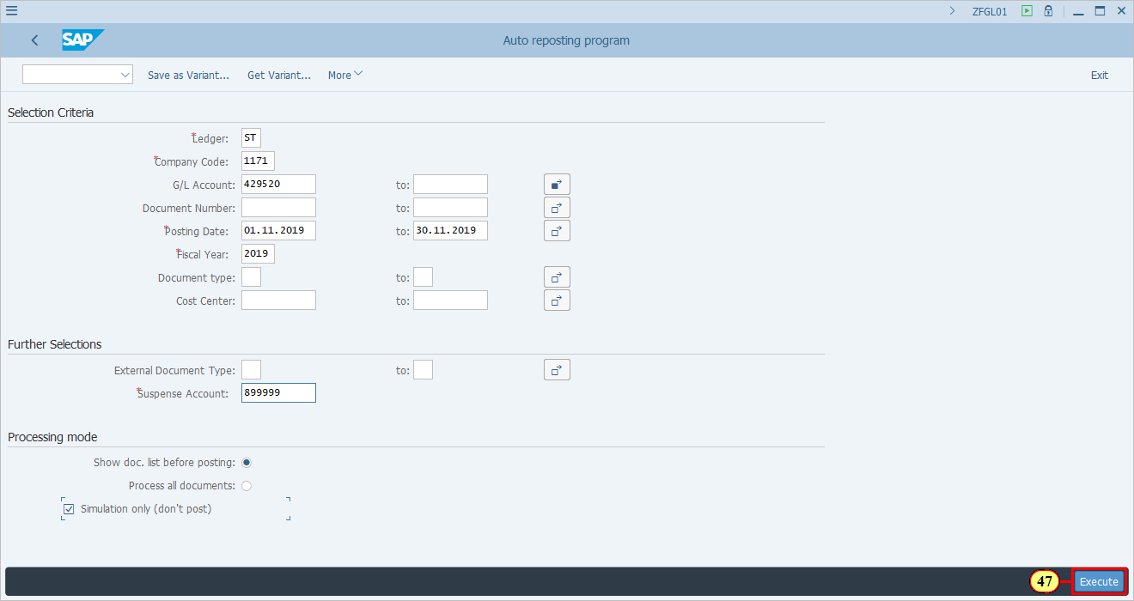
  As you can see here, the system warns you that postings have been made for your selected period.  You may confirm the message and press Enter to continue.  [48] ENTER is now pressed. | 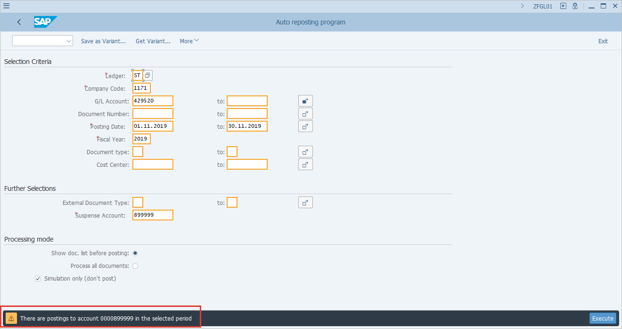
  As expected, the system tells you that there's no record selected. This is because we have just posted all the items subject to Functional Area Adjustment in the previous steps and there's nothing more to be selected for posting. | 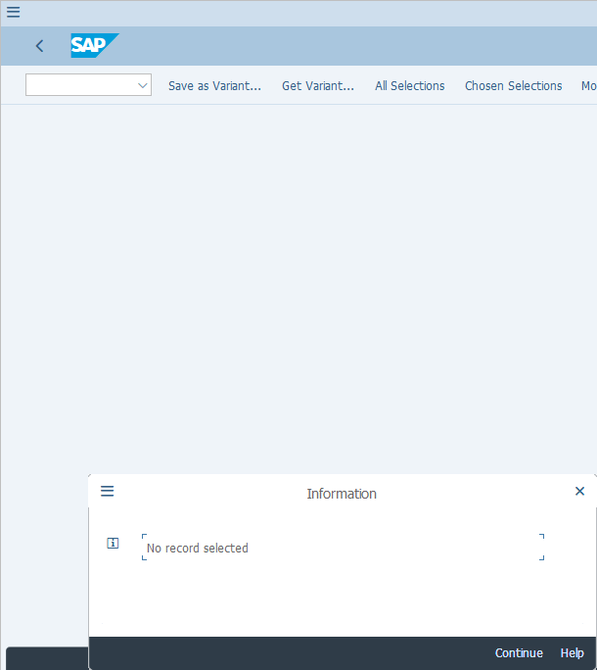
  In the next few steps, we will demonstrate that we can re-run ZFGL01 for selected original document if the last Functional Area Adjustment posting for this document is reversed.  Please note this is an unusual scenario which should only occur in exceptional cases, e.g. something is wrong and needs to be adjusted after ZFGL01 is already run, which requires a re-run of ZFGL01 after the correction.  Click to continue.  [49] We need to reverse the last Functional Area Adjustment Posting. This is done via FB08.  Enter the last Functional Area Adjustment posting document in the field. | 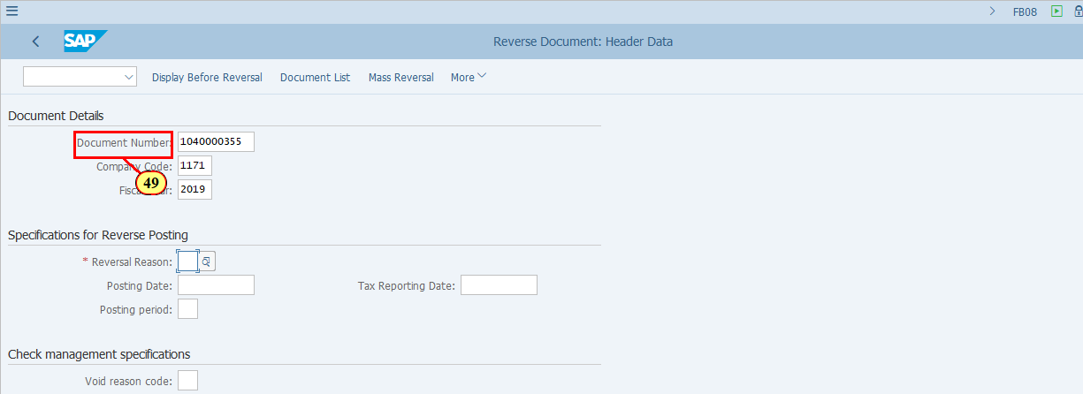
  Also provide a Reversal Reason before clicking Post.  [50] Click Post . | 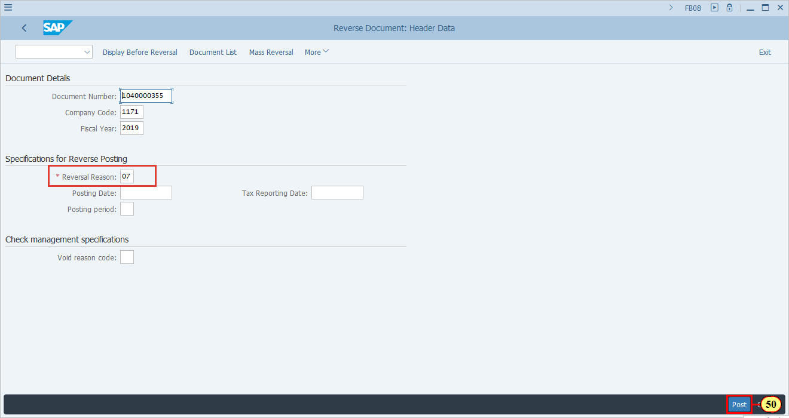
  The message confirms that the document has been reversed. This means that the system now deems that you do not have a valid Functional Area Adjustment posting for the original document. | 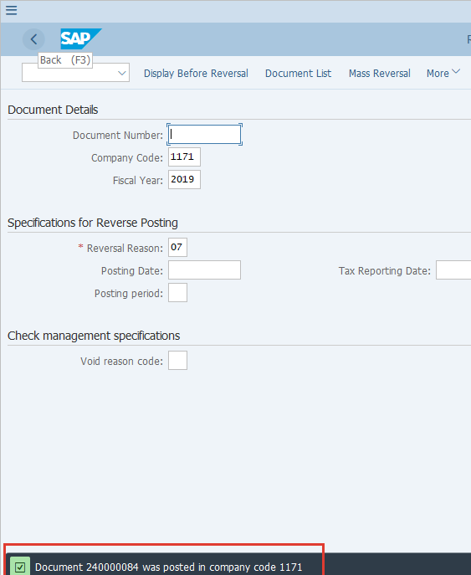
  Now come back to transaction ZFGL01. Select the same variant and make sure all the parameters are the same as what you wish to post for Functional Area Adjustment for the given period. You do not need to specify a document here as the system knows for which original document a Functional Area Adjustment has been made and for which not.  [51] Click Execute .  You can also press F8. | 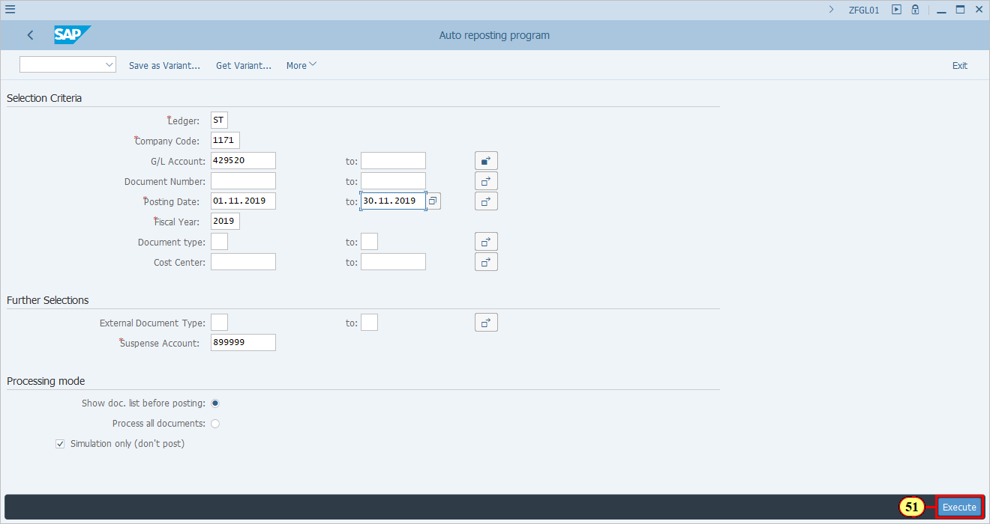
[52] Confirm the warning message and press ENTER to continue. | 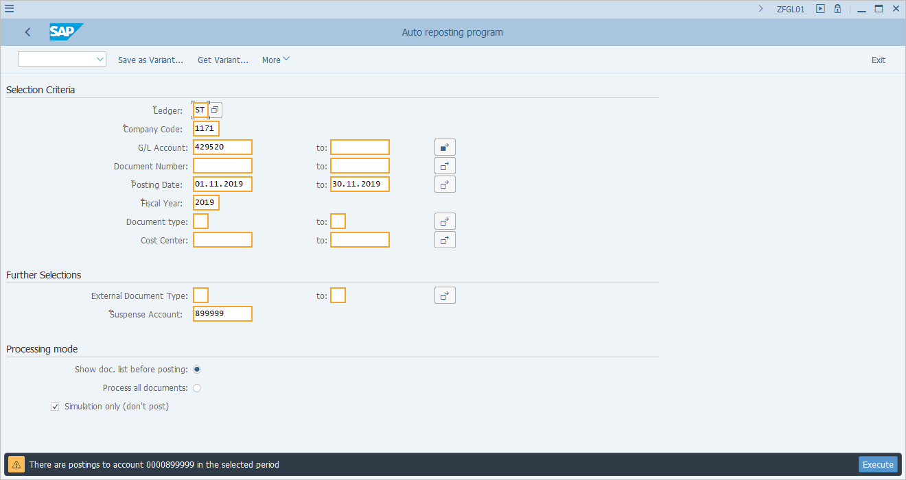
  As you can see here, although we have made a selection (on the ZFGL01 selection screen) for all the G/L subject to Functional Area Adjustment, the transaction knows that only for this one origial document there's no valid Functional Area Adjustment posting, because we just reversed it.  You may continue to complete the Functional Area Adjustment posting for this document following the instruction described in the earlier steps. | 